PA7 Report

**Problem (a)**

The following figures (fig.1 to fig. 3) show the same optimized structure but with different $r_{min}$. Since the $r_{min}$ is used to do the filtering and tells how big your element is. If $r_{min}=1.0$, there is no filter and each element will not be affected or averaged by adjacent elements. That is what fig. 1 show, a ill-posed structure. When $r_{min}=1.5$, there is a filter now and this will let each element take adjacent three to four elements into consideration and each element size is estimated 1.5. When $r_{min}=5.0$, the elements’s size will be too large. And the averaged number will be between 0 and 1, that is why there is some gray area in the fig. 3.

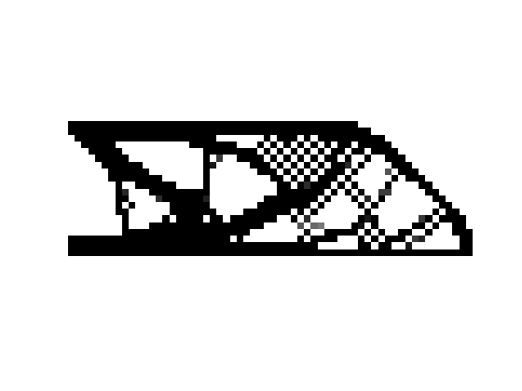

Fig. 1 Optimized structure with rmin = 1.0



Fig. 2 Optimized structure with rmin = 1.5

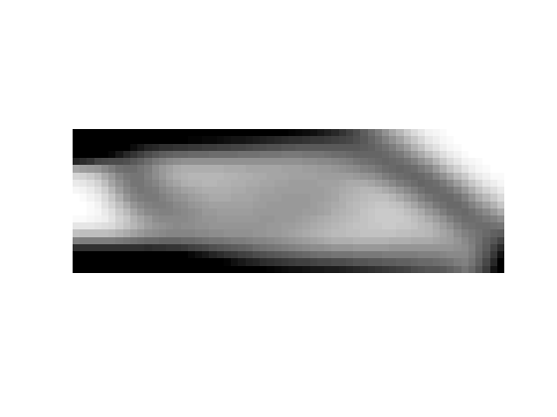

Fig. 3 Optimized structure with rmin = 5.0

**Problem (b)**

The following figures(fig. 4 to fig. 6) show the same optimized structure but with different p. P is penalization factor and sufficiently big “p” will penalize internediate densities, resulting in “black and white” designs. That is why fig. 6 has the most clear image when compared to fig. 4 and fig. 5.

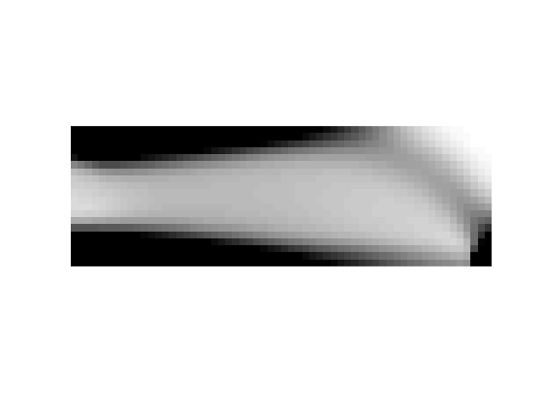

Fig. 4 Optimized structure with p = 1.0

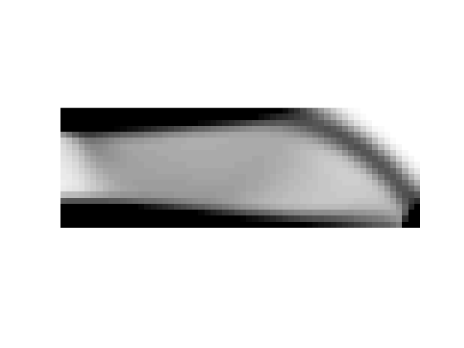

Fig. 5 Optimized structure with p = 2.0

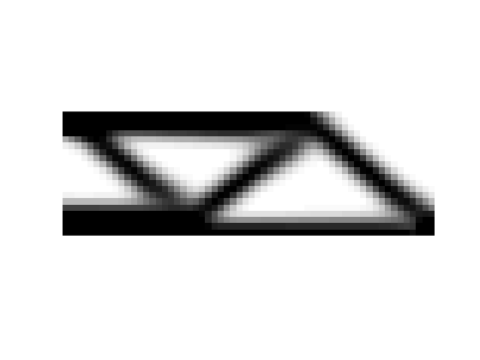

Fig. 6 Optimized structure with p = 3.0

**Problem (c)**

Fig. 7 shows a topology optimized cantilever beam. It has two load cases, one on the top and one on the bottom. There is a hole in it and the left edge is clamped to a wall.

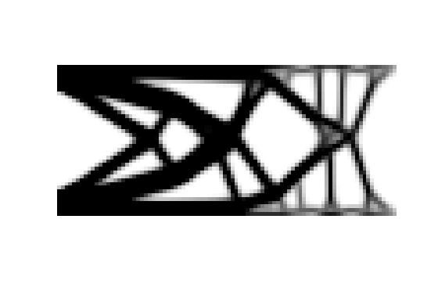

Fig. 7 Topology optimization of a cantilever beam with a hole under 2 different load cases

**Modified code:**

function PA7(nelx,nely,volfrac,penal,rmin);

% INITIALIZE

x(1:nely,1:nelx) = volfrac;

% ADD A HOLE

for ely = 1:nely

for elx = 1:nelx

if sqrt((elx-nelx*2/3.)^2+(ely-nely/2.)^2)<nely/3.

passive(ely,elx) = 1;

x(ely,elx) = 0.001;

else

passive(ely,elx) = 0;

end

end

end

loop = 0;

change = 1.;

% START ITERATION

while change > 0.01

loop = loop + 1;

xold = x;

% FE-ANALYSIS

[U]=FE(nelx,nely,x,penal);

% OBJECTIVE FUNCTION AND SENSITIVITY ANALYSIS

[KE] = lk;

c = 0.;

for ely = 1:nely

for elx = 1:nelx

n1 = (nely+1)*(elx-1)+ely;

n2 = (nely+1)* elx +ely;

dc(ely,elx) = 0.;

for i = 1:2

Ue = U([2*n1-1;2*n1; 2*n2-1;2*n2; 2*n2+1;2*n2+2; 2*n1+1;2*n1+2],i);

c = c + x(ely,elx)^penal*Ue'*KE*Ue;

dc(ely,elx) = dc(ely,elx) - penal*x(ely,elx)^(penal-1)*Ue'*KE*Ue;

end

end

end

% FILTERING OF SENSITIVITIES

[dc] = check(nelx,nely,rmin,x,dc);

%passive(1:nely,1:nelx) = 0;

% DESIGN UPDATE BY THE OPTIMALITY CRITERIA METHOD

[x] = OC(nelx,nely,x,volfrac,dc);

% PRINT RESULTS

change = max(max(abs(x-xold)));

disp([' It.: ' sprintf('%4i',loop) ' Obj.: ' sprintf('%10.4f',c) ...

' Vol.: ' sprintf('%6.3f',sum(sum(x))/(nelx*nely)) ...

' ch.: ' sprintf('%6.3f',change )])

% PLOT DENSITIES

colormap(gray); imagesc(-x); axis equal; axis tight; axis off;pause(1e-6);

end

%%%%%%%%%% OPTIMALITY CRITERIA UPDATE %%%%%%%%%%%%%%%%%%%%%%%%%%%%%%%%%%%%%%

function [xnew]=OC(nelx,nely,x,volfrac,dc)

l1 = 0; l2 = 100000; move = 0.2;

while (l2-l1 > 1e-4)

lmid = 0.5*(l2+l1);

xnew = max(0.001,max(x-move,min(1.,min(x+move,x.*sqrt(-dc./lmid)))));

%xnew( find(passive) ) = 0.001;

if sum(sum(xnew)) - volfrac*nelx*nely > 0;

l1 = lmid;

else

l2 = lmid;

end

end

%%%%%%%%%% MESH-INDEPENDENCY FILTER %%%%%%%%%%%%%%%%%%%%%%%%%%%%%%%%%%%%%%%%

function [dcn]=check(nelx,nely,rmin,x,dc)

dcn=zeros(nely,nelx);

for i = 1:nelx

for j = 1:nely

sum=0.0;

for k = max(i-floor(rmin),1):min(i+floor(rmin),nelx)

for l = max(j-floor(rmin),1):min(j+floor(rmin),nely)

fac = rmin-sqrt((i-k)^2+(j-l)^2);

sum = sum+max(0,fac);

dcn(j,i) = dcn(j,i) + max(0,fac)*x(l,k)*dc(l,k);

end

end

dcn(j,i) = dcn(j,i)/(x(j,i)*sum);

end

end

%%%%%%%%%% FE-ANALYSIS %%%%%%%%%%%%%%%%%%%%%%%%%%%%%%%%%%%%%%%%%%%%%%%%%%%%%

function [U]=FE(nelx,nely,x,penal)

[KE] = lk;

K = sparse(2*(nelx+1)*(nely+1), 2*(nelx+1)*(nely+1));

F = sparse(2*(nely+1)*(nelx+1),2); U = zeros(2*(nely+1)*(nelx+1),2);

for elx = 1:nelx

for ely = 1:nely

n1 = (nely+1)*(elx-1)+ely;

n2 = (nely+1)* elx +ely;

edof = [2*n1-1; 2*n1; 2*n2-1; 2*n2; 2*n2+1; 2*n2+2; 2*n1+1; 2*n1+2];

K(edof,edof) = K(edof,edof) + x(ely,elx)^penal*KE;

end

end

% DEFINE LOADS AND SUPPORTS (HALF MBB-BEAM)

% DEFINE LOAD 1

for elx = (nelx/2+1):(nelx+1)

node = (nely+1)*(elx-1)+1;

F(2*node,1) = 10;

end

F(2*((nely+1)*nelx/2+1),1) = 5;

F(2*((nely+1)*nelx+1),1) = 5;

% DEFINE LOAD 2

for elx = (nelx/2+1):(nelx+1)

node = (nely+1)*(elx-1)+nely+1;

F(2*node,2) = -10;

end

F(2*((nely+1)*nelx/2+nely+1),2) = -5;

F(2*((nely+1)*nelx+nely+1),2) = -5;

fixeddofs = [1:2*(nely+1)];

alldofs = [1:2*(nely+1)*(nelx+1)];

freedofs = setdiff(alldofs,fixeddofs);

% SOLVING

U(freedofs,:) = K(freedofs,freedofs) \ F(freedofs,:);

U(fixeddofs,:)= 0;

%%%%%%%%%% ELEMENT STIFFNESS MATRIX %%%%%%%%%%%%%%%%%%%%%%%%%%%%%%%%%%%%%%%%

function [KE]=lk

E = 1.;

nu = 0.3;

k=[ 1/2-nu/6 1/8+nu/8 -1/4-nu/12 -1/8+3*nu/8 ...

-1/4+nu/12 -1/8-nu/8 nu/6 1/8-3*nu/8];

KE = E/(1-nu^2)*[ k(1) k(2) k(3) k(4) k(5) k(6) k(7) k(8)

k(2) k(1) k(8) k(7) k(6) k(5) k(4) k(3)

k(3) k(8) k(1) k(6) k(7) k(4) k(5) k(2)

k(4) k(7) k(6) k(1) k(8) k(3) k(2) k(5)

k(5) k(6) k(7) k(8) k(1) k(2) k(3) k(4)

k(6) k(5) k(4) k(3) k(2) k(1) k(8) k(7)

k(7) k(4) k(5) k(2) k(3) k(8) k(1) k(6)

k(8) k(3) k(2) k(5) k(4) k(7) k(6) k(1)];